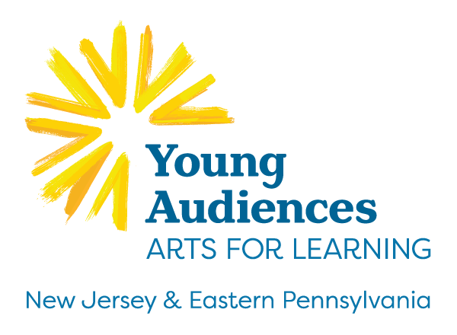

How to Apply:

Complete the application by typing in the fields provided. Deadline for applying is October 15, 2021.
- Print the application.

Sign the application (Principal and Project Coordinator Signatures are required).
- Scan to PDF and return it to Young Audiences via email to TAHIRA@yanjep.org.

For more information call TAHIRA at 866-500-9265.
Name of School
Address
City
State
Zip
Phone
Number of Students
Grade Levels Served
Free/Reduced School Meal Rate

Required Signatures—please sign, scan and include in your application.
Principal Signature
Principal Name
Principal Email
Project Coordinator Signature
Project Coordinator Name
Project Coordinator Title
Project Coordinator Email

Please answer the following questions for a maximum of three pages (add separate pages as necessary):

- Why do you feel your school should be selected for the United We Create scholarship program?

- Is there a special need or challenge faced by your school that the United We Create programming can help meet? Example, school is focusing on character education to promote positive behaviors and reduce instances of bullying.

- Describe your school’s climate. Please include how your school addresses or needs to address: access to arts education, anti-bullying, diversity and inclusion, access to resources about Muslim cultures.

- Describe your student body. Please share the ethnic and socio-economic breakdown, cultural and religious (if known) makeup, and any other relevant details.

- Programs will be available virtually. Please indicated which virtual format your school prefers. Please check all that apply.:
  - Live-streamed
  - Recorded
  - Hybrid (Combination of recorded with Live Q & A with the artist)

- Several of the components in this project must take place during the school day including assemblies and sixteen (16) in-class student workshops. How do you anticipate scheduling time for the artists to work with students during the school day? How do you anticipate scheduling time for two 90-minute PD workshops for teachers and administrators?

- What community partners will you invite to participate in the Family Arts/Community Event? How will they connect to the United We Create program? Will this be an evening or daytime event?

- The family engagement workshop is available virtually. Please indicated which virtual format your school prefers. Please check all that apply.:
  - Live-streamed
  - Recorded
  - Hybrid (Combination of recorded with Live Q & A with the artist)

- Are you currently receiving arts funding from any other grants or organizations?
  - No
  - Yes, please describe the projects you are doing

- To participate in UWC, it is required that schools assist with facilitating the assessment of the program, which will involve participants taking on-line pre and post assessment surveys. We will also ask select schools to participate in deeper assessment that may include student, educator and administrator interviews and a student focus group.
Do you anticipate any barriers to assisting with the assessment described above?
  - No
  - Yes, please explain

