Meet the Feeling Friends!
An Introduction to Emotions

Creative Beginnings Dramatic Play Program Supplement
for Children Ages 4 to 6 and their caregivers

By Young Audiences Teaching Artist Summer Dawn Reyes

How to Use This Supplement
This supplement is designed to be used as part of the Creative Beginnings Dramatic Play residency and reinforces several skills introduced and developed by Young Audiences Teaching Artists. Ideally, it should be used by teachers and/or at-home caregivers immediately after Day 1 of the residency.
Students who complete this supplement will be able to:
- Recognize, identify and describe all basic emotions (happy, sad) and some advanced emotions (thoughtful, elated)
- Recognize how people use their faces, bodies and words to express their emotions. (Keen facilitators can also note the use of vocal intonation in dynamic readings of the text)
- Identify their emotions and share them by using I Statements
- Ask others how they are feeling
- Engage in creative play that inspires cross-curricular learning opportunities. Secondary skills include counting, sorting, drawing, interactive play, storytelling, sensory development, gross and fine motor development
- Describe and name some basic emotionally healthy behaviors in line with Social Emotional Learning Competencies
- Use critical thinking and problem-solving skills to create and tell story
Teachers and/or at-home caregivers should encourage children to use their imagination and engage with the act of wondering as children get to know the Feeling Friends and make connections between the emotional experiences of the Feeling Friends and their personal lives by watching and listening closely. Each scenario offers guiding questions to engage the imagination. The Feeling Friend paper dolls, scenarios and questions are intended as strategies to nurture children’s exploration and play.
This supplement also offers opportunities to build literacy and writing skills for students who use gesture paired with one or two words to communicate; those who make marks on a page; those who represent ideas with pictures, letters and words; as well as those who are using words to create sentences.

About the Author and Artist
Summer Dawn Reyes is a theater teaching artist for Young Audience Arts for Learning New Jersey and Eastern Pennsylvania (YA) and is part of the Creative Beginnings and Dodge Theatre to Learn programs. She is also the founder of In Full Color (IFC), an organization that empowers women of color through education and the arts. IFC has received two commendations from the New Jersey State Assembly and the Jersey City Arts Council's Performing Arts Award.
Summer is also the winner of the Permanent Career Award in Literature from the Society of Arts and Letters-NJ and the N.J. Governor's Award in Arts Education. You may also know her as an events coordinator, arts journalist, writer and actress. Visit InFullColor.org or follow her @infullcolorus_

Meet the Feeling Friends! An Introduction to Emotions
Chapter One: What are Emotions?
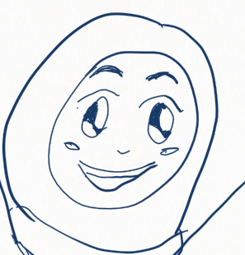
Hello, friend!
How are you feeling today?
Show someone how you feel by using your face. (You can smile or frown!)
Show someone how you feel by using your body. (You can jump or cross your arms!)
What word describes how you feel today?
Are you happy? Are you tired? Are you sad? -- The word you chose is the emotion you are feeling!

An emotion is a strong feeling like happiness, sadness, excitement or fear.
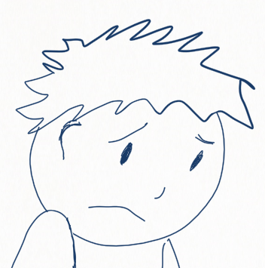
When you feel happy, your emotion or feeling is happiness. People often use “emotion” and “feeling” to mean the same thing.
We express or share our emotions by using our faces, our bodies and our words. Sharing our emotions helps us let people know how we are feeling.
In theater, actors and storytellers use their faces, bodies, and words to show how characters are feeling. They can also use their voices to show feelings!
On the next pages, we’ll learn more about emotions by becoming storytellers.
Let’s start by meeting the Feeling Friends! Look closely at the faces and bodies of each Feeling Friend. Say hello to each Feeling Friend by making your face look like theirs. Notice how you feel.

Feeling Friend Emotions Chart
Here are some feelings we all feel from time to time!

Rashida Anthony Yoko

Happy
Loved
Hopeful
Calm
Terrific
Sad
Lonely
Stressed
Worried
Disappointed
Scared
Fearful
Nervous
Shocked
Surprised

Fatima Jamal Aurora

Excited
Elated
Cheerful
Playful
Silly
Bored
Confused
Interested
Grumpy
Thoughtful
Angry/Mad
Irritated
Frustrated
Annoyed
Moody

Feeling Friend One: “Hey! Nice to meet you. I’m Rashida. I just went to the park with my dad. It was fun!”

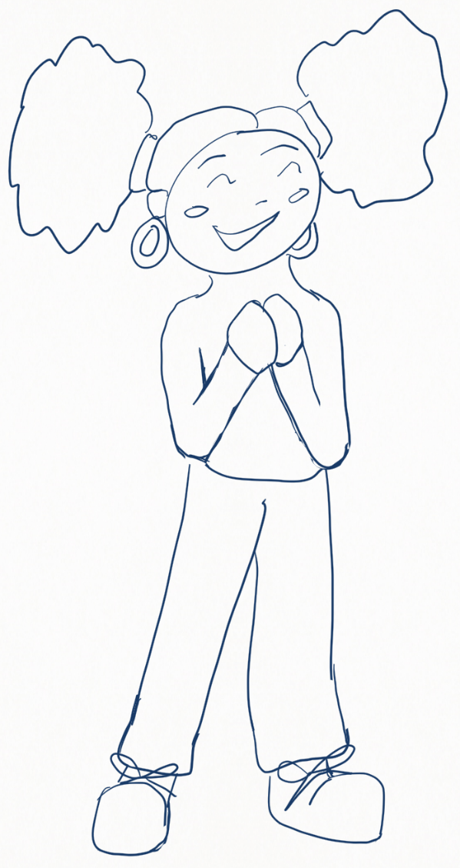
How Do They Feel?
Use these guiding questions to figure out how Rashida feels

1. Look closely at the picture. What is Rashida’s face or body doing to show emotion?

2.Show someone what Rashida is doing to show emotion with your face and body.

3. How do you think Rashida feels? Look at the Feeling Friends Emotions Chart on
page 5 and choose a feeling word.

4. Share a time when you felt Rashida’s emotion.

Good job! Now let’s do a fun activity.

Creative Activity One
What do you think Feeling Friend Rashida did at the park to have fun? Imagine you met Rashida at the park. Share what you and Rashida did to have fun.

Use your face, body and movement to act out what you and Rashida did. Ask someone you love to guess what you’re doing!

Think about how an actor or storyteller would use their face, body and movement to show their character having fun.

Ask your loved one to create a sound that helps to show the emotion you felt while having fun at the park.

Feeling Friend Two: “Hi. I’m sorry, I don’t feel like talking today. I just lost my favorite toy. I can’t find it anywhere.”

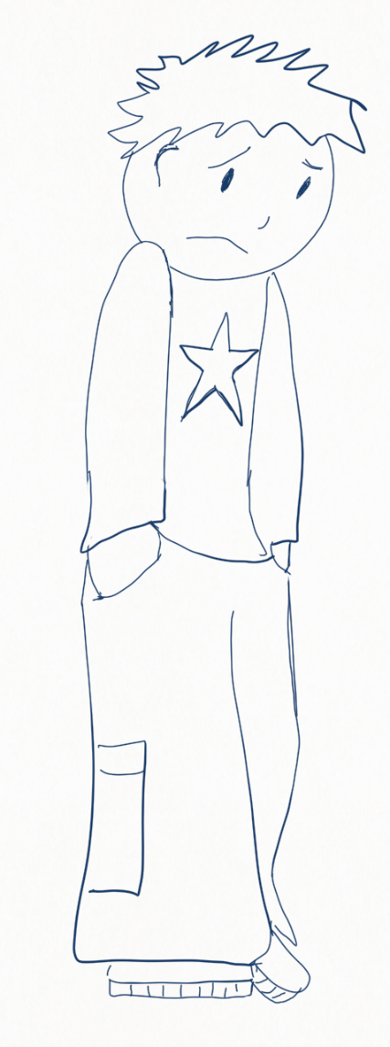
How Do They Feel?
Use these guiding questions to figure out how Anthony feels

1. Look closely at the picture. What is Anthony’s face and body doing to show emotion?
2. Show what Anthony is doing to show emotion with your face and body.
3. How do you think Anthony feels? Look at the Feeling Friends Emotions Chart on page 5 and choose a feeling word.
4. Share a time when you felt Anthony’s emotion.
You’re getting so good at this! Let’s enjoy another activity.

Creative Activity Two
Find your three favorite toys. Share them with Feeling Friend Anthony.

If your favorite toys went on an adventure together, what would they do?

Create a story that includes all three of your favorite toys and use your toys to share the story with someone you love.

How do actors use their faces, bodies, voices and movement to tell stories?

How can you move your toys and their bodies to show how they feel?

How can you use your own face and voice to help tell the story of your toys’ adventures?

Feeling Friend Three: “I think the monster under my bed is looking for us. They’re going to catch us! What should we do?”
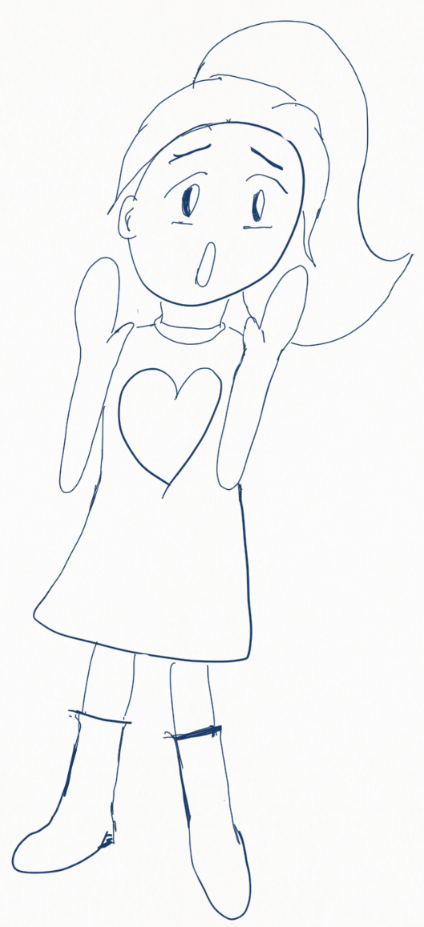
How Do They Feel?
Use these guiding questions to figure out how Yoko feels

1. Look closely at the picture. What is Yoko’s face or body doing to show emotion?

2. Show what Yoko is doing to show emotion with your face and body.

3. How do you think Yoko feels? Look at the Feeling Friends Emotions Chart on page 5 and choose a feeling word.

4. Share a time when you felt Yoko’s emotion.

You really know your emotions! The next activity will be really fun.

Creative Activity Three
What kind of monster could be under Feeling Friend Yoko's bed? How do you think the monster will make you and Yoko feel? Are they scary or silly?

How do you think the monster will feel if you touched them? Slimy or fuzzy? Find something in your home that would feel like the monster.

What sort of noise might they make? Find something in your home that would sound like the monster.

What would the monster smell like? Find something in your home that would smell like the monster.

If you shared a snack with the monster, what would it taste like? Find something in your home that you would eat with the monster.

Draw the monster under Yoko’s bed, and be sure to include you and Yoko.

Feeling Friend Four: “Mama is home from work! I can’t wait to show her what Papa and I cooked today for dinner.”
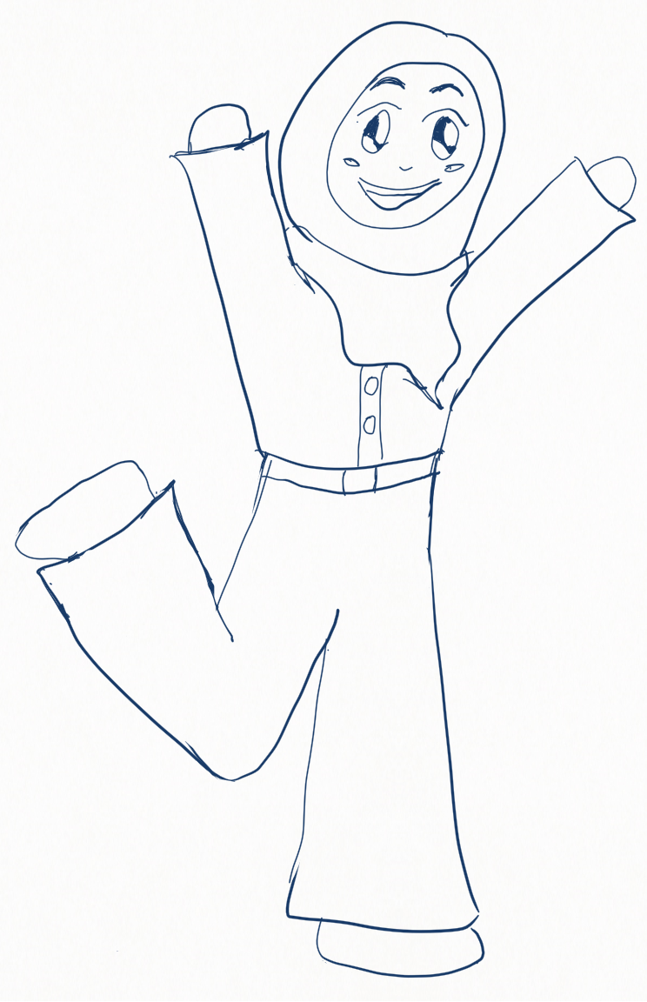
How Do They Feel?
Use these guiding questions to figure out how Fatima feels

1. Look closely at the picture. What is Fatima’s face or body doing to show emotion?

2. Show what Fatima is doing to show emotion with your face and body.

3. How do you think Fatima feels? Look at the Feeling Friends Emotions Chart on page 5 and choose a feeling word.

4. Share a time when you felt Fatima’s emotion.

Let’s see what fun activity we can do with Fatima!

Creative Activity Four
What kind of food do you think Fatima might have cooked with her father? What food would you like to make with your caregiver?

Go with a grown-up into your kitchen for a fun scavenger hunt!

- Find one food you haven’t tried before
- Find two foods that would taste good together
- Find three foods that are the same color
- Find four foods that smell good
- Find five foods that begin with the letter C
- Find six foods that are sweet
- Find seven foods you could eat for breakfast
- Find eight foods you could eat for dinner
- Find nine foods both you and your caregiver like
- Find a food you have more than 10 of in your home

Then, make something delicious together and enjoy a yummy meal!

Feeling Friend Five: “I tried helping my friend Anthony with the math problem, but he still doesn’t get it. I don’t know how to help him.”

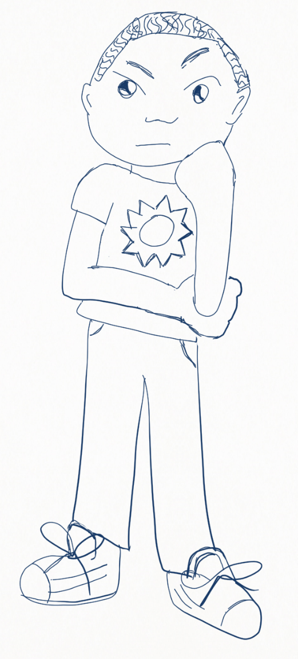
How Do They Feel?
Use these guiding questions to figure out how Jamal feels

1. Look closely at the picture. What is Jamal’s face or body doing to show emotion?

2. Show someone what Jamal is doing to show emotion with your face and body!

3. How do you think Jamal feels? Look at the Feeling Friends Emotions Chart on page 5 and choose a feeling word.

4. Share a time when you felt Jamal’s emotion.

You did great! What do you think we can do with Jamal?

Creative Activity Five
Draw your favorite animal and ask someone you love to draw their favorite animal next to yours.

- How many legs do the two animals have together?
- How many arms?
- How many tails?
- How do both of these animals move?
- What sounds do they make?

Imagine an adventure the two animals might have together. Tell your story to your loved one. Ask them to find a place in the story to add a sound.

Think about the way actors use their faces, bodies, voices and movement to tell stories. How can you use your face, body, voice and movement to tell the story you’ve created about your animals?

Feeling Friend Six: “I don’t want to help translate today. It’s not my fault my teacher doesn’t speak Spanish! How can I help Ms. Jones understand that I’m too tired?”
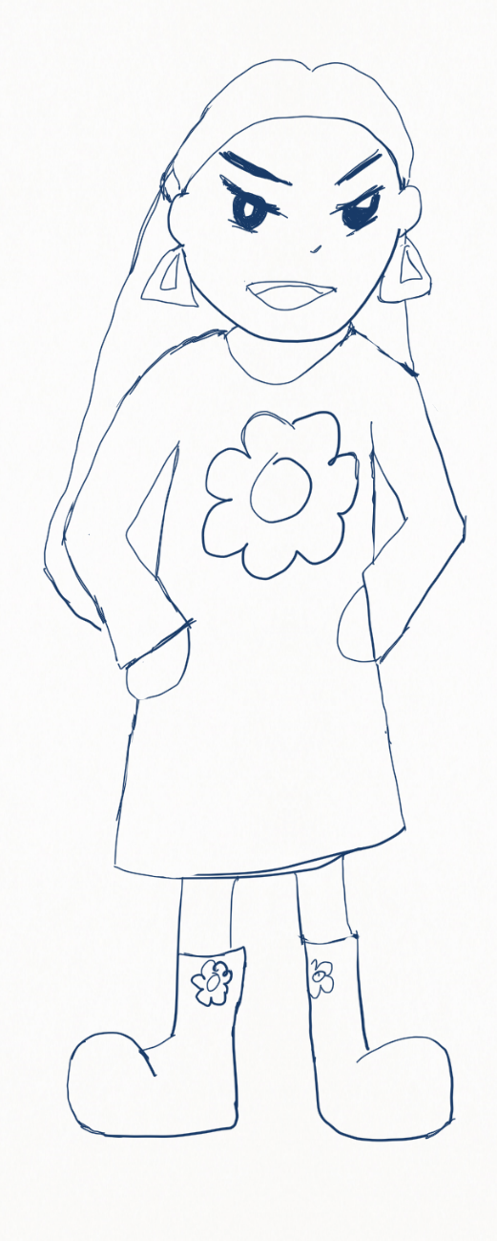
How Do They Feel?
Use these guiding questions to figure out how Aurora feels

1. Look closely at the picture. What is Aurora’s face or body doing to show emotion?

2. Show someone what Aurora is doing to show emotion with your face and body!

3. How do you think Aurora feels? Look at the Feeling Friends Emotions Chart on page 5 and choose a feeling word.

4. Share a time when you felt Aurora’s emotion.

Now it’s time for a fun activity!

Creative Activity Six
Gather everyone in your home for a fun theater game called Pass the Emotion!

Stand in a circle. The oldest person in the circle will think of a simple emotion, then say it to the person to their right in a way that also shows the emotion. You can say “Angry!” with a growl, or “Excited!” with a squeal.

This person then passes the emotion to the person to their right, and this continues around the circle until it comes back to the first person.

As your group gets better at listening and passing the sound, you can try adding gestures and movement! How can you use your faces and bodies to show the emotion?

If you live in a home with two to three people, you can play a version of the game where each person adds a new emotion during their turn. Each person has to remember all the emotions and say them in the right order, or they're out! The winner is the last person standing.

Chapter One Review
Now you’ve met all of our Feeling Friends! Every day, we all feel many different emotions and it’s important to learn how to identify and express them. You’ve learned how people use their faces to express emotion:
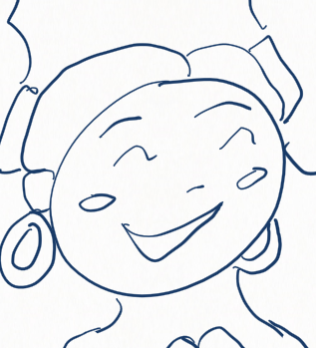
- Smiling (Happy, Excited)
- Frowning (Sad)
- Raising Their Eyebrows (Excited, Scared)
- Furrowing Their Eyebrows (Angry)

You’ve learned how people use their bodies to express emotion:
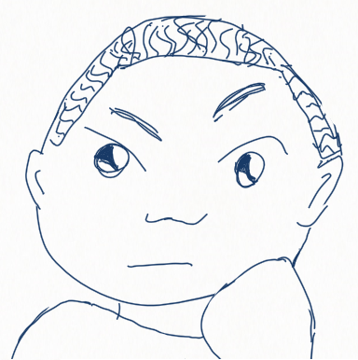
- Touching Their Chin (Thoughtful)
- Putting Hands on Hips (Angry)
- Putting Hands in Pockets (Sad)
- Throwing Hands in the Air (Excited)
- Jumping Up (Excited)
- Putting Hands Up To Face (Scared)

Most importantly, you’ve learned to listen to what our friends are saying to understand how they might feel. Fantastic work!
In Chapter Two, we’ll bring scenes (short stories) starring our Feeling Friends to life. In each scene, think about how the Feeling Friends can express or share their emotions with each other.

Chapter Two: Becoming Feeling Friends
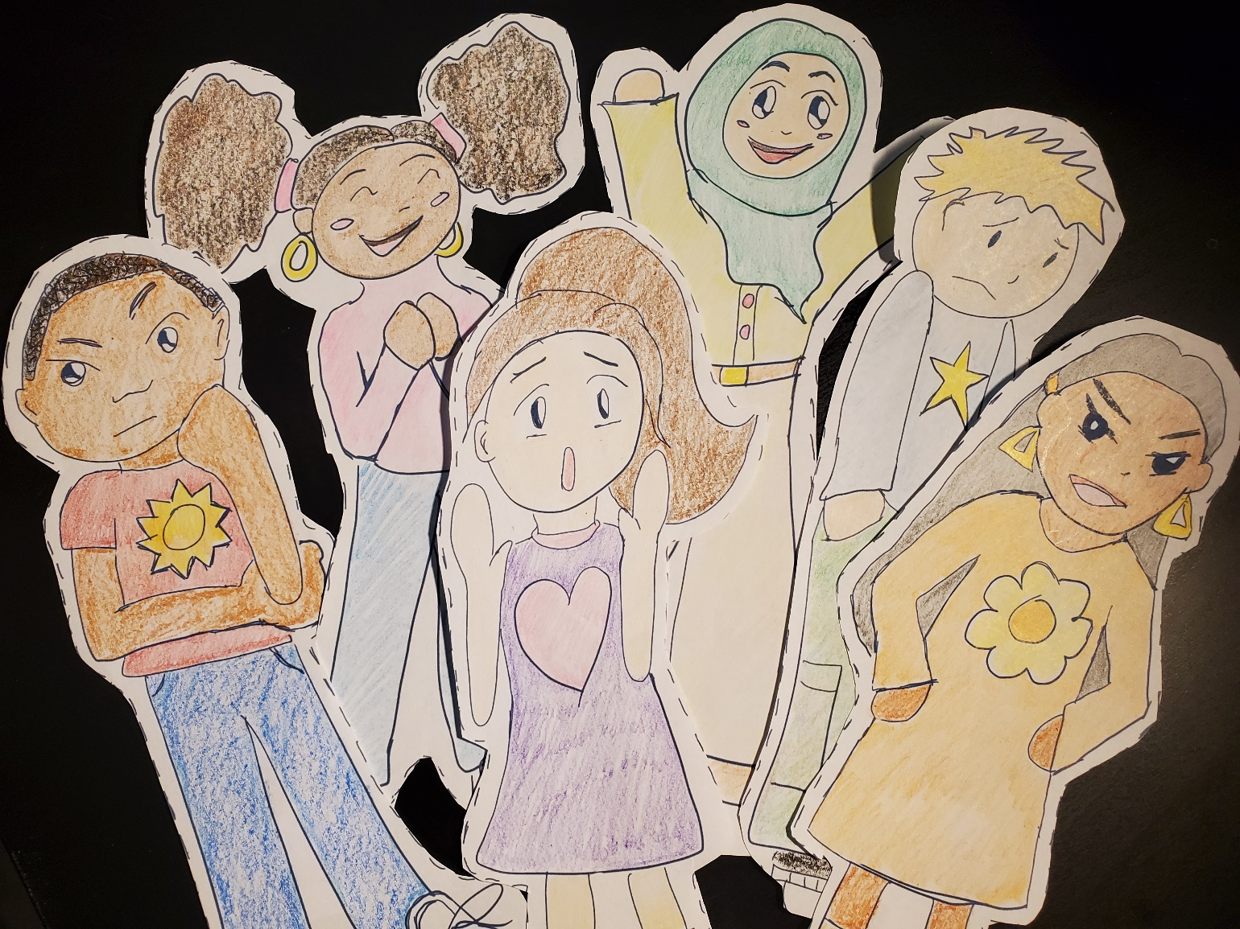
Look for a Bonus Activity on page 34 with fun art ideas.

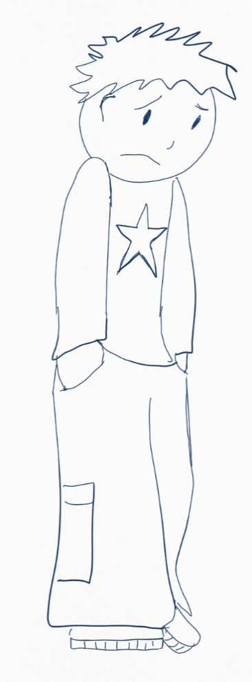
Scene One: The Birthday Party – Version A
Rashida saw her friend Anthony in the cafeteria and skipped over to say hello. “Hey, Anthony! What’s up?” she asked.

“Nothing,” said Anthony in a soft voice. He kept his head down and didn’t look at Rashida.

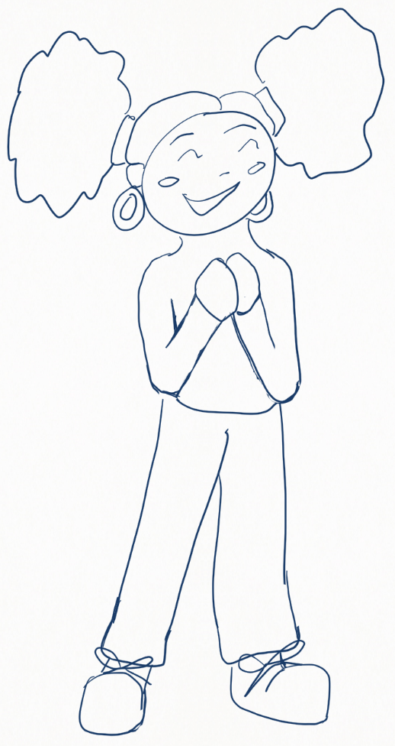
“Uh, OK,” said Rashida with a shrug. He was usually never this quiet. “See ya at Jamal’s later!”

Suddenly, Anthony began to cry.

Rashida gasped. “Oh no! What’s wrong?”

“Just leave me alone! You’re so annoying!” Anthony ran away, leaving Rashida scratching her head.

Guiding Questions: The Birthday Party – Version A
What happened in the story?

What is Rashida doing with her face or body to show how she feels at the beginning of the story? Show someone with your face and body.

How do you think Rashida feels at the beginning of the story? Use the Feeling Friends Emotions Chart on page 5 and choose a feeling word.

What is Rashida doing with her face or body to show how she feels at the end of the story? Show someone with your face and body.

How do you think she feels? Use a feeling word.

What is Anthony doing with his face or body to show how they feel? Show someone with your face and body.

How do you think Anthony feels? Use the Feeling Friends Emotions Chart on page 5 and choose a feeling word.

Scene One: The Birthday Party – Version B
Rashida saw her friend Anthony in the cafeteria and skipped over to say hello. “Hey, Anthony! How are you?” She noticed he was looking down at the ground. “Why are you frowning?” she asked.

“I am feeling sad,” he said.

“Why are you feeling sad?” asked Rashida.

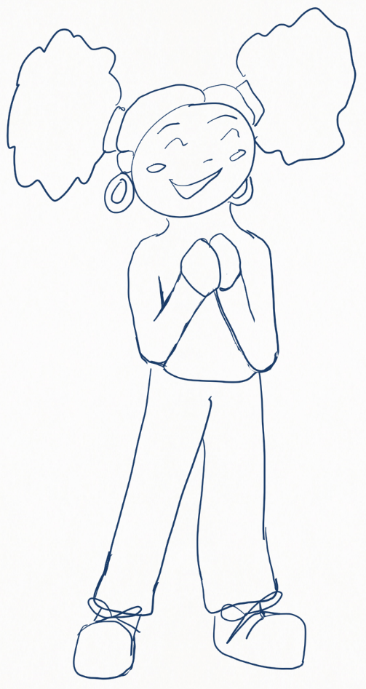
“My dad is working late tonight and can’t pick me up,” said Anthony. “I’m going to miss Jamal’s birthday party! He’s my best friend, I don’t want to let him down.”

Rashida smiled. “No worries! You can ride with me and my mom. I’ll ask her after school. I’m sure she’ll say yes.”

“Really?” Anthony gasped.

“Really! See ya at Jamal’s later!” she beamed.

“See ya!” said Anthony, who was now wearing a big smile.

Guiding Questions: The Birthday Party – Version B
What happened in the story? How is it different from Version A?

Rashida asks Anthony how he is after noticing two things he is doing with his face and body. What does she notice?

Anthony uses an I Statement to express that he is sad. An I Statement is a sentence that starts with the word “I,” like “I am feeling sad.” How do you feel today? Can you use an I Statement to share how you feel?

Why does Anthony say he feels sad?

How does Rashida offer to help Anthony?

What is Anthony doing with his face and body to show how he feels at the end of the story? Show someone with your face and body.

How does Anthony feel at the end? Use the Feeling Friends Emotions Chart on page 5 and choose a word.

Creative Activity
What would you do if you were friends with Anthony and you saw him feeling sad. Use your imagination to tell a story that shares two ways you would help Anthony.

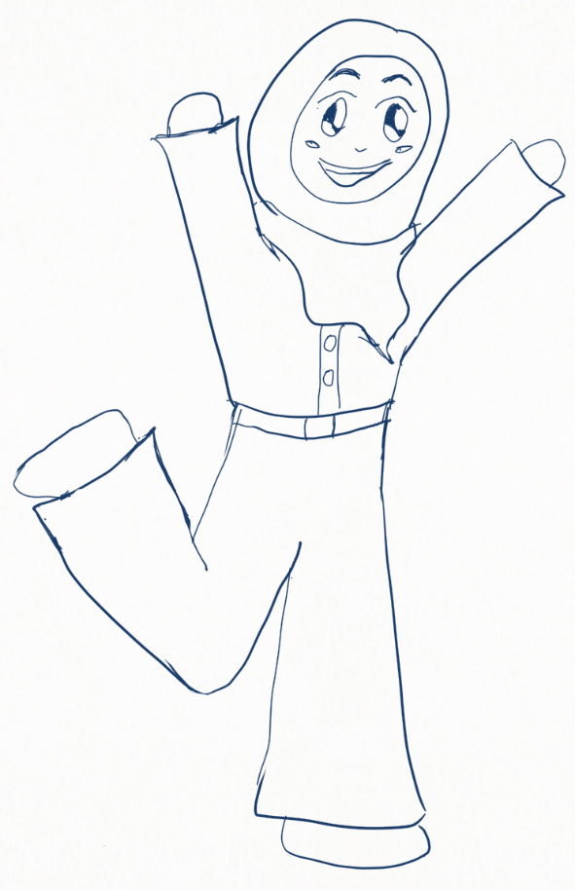
Scene Two: Wonderworld – Version A
At last, the girls had arrived at Wonderworld! The amusement park was Fatima’s favorite place. She jumped up high. “I can’t wait to ride the rollercoaster! Look how high it goes!” she squealed.

Her best friend, Yoko, watched as the rollercoaster riders went zoom! They turned upside-down in loop-de-loops. When the riders all screamed, “Ahhhhh!” Yoko did too.
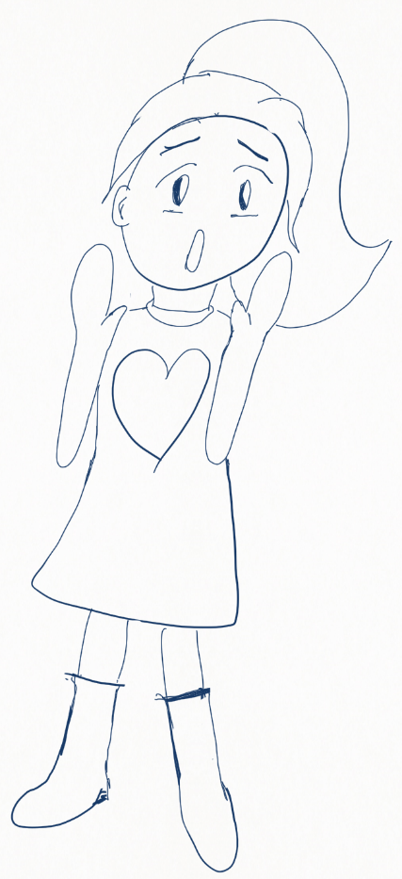
“It’s too fast!” she cried. “I don’t think it’s safe, Fatima.”

“What are you, a little baby?” laughed Fatima.

Yoko’s eyes filled with tears. She crossed her arms and didn’t talk to Fatima the rest of the day.

Fatima frowned and stomped her foot. “You’re no fun, Yoko. Let’s go home.”

Guiding Questions: Wonderworld – Version A
What happened in the story?

What is Fatima doing with her face or body to show how she feels at the beginning of the story? Show someone with your face and body.

How do you think Fatima feels at the beginning of the story? Use the Feeling Friends Emotions Chart on page 5 and choose a feeling word.

What is Fatima doing with her face or body to show how she feels at the end of the story? Show someone with your face and body.

How do you think Fatima feels at the end of the story? Use a feeling word.

What is Yoko doing with her face or body to show how she feels after she sees the rollercoaster? Show someone with your face and body.

How do you think Yoko feels? Use the Feeling Friends Emotions Chart on page 5 and choose a feeling word.

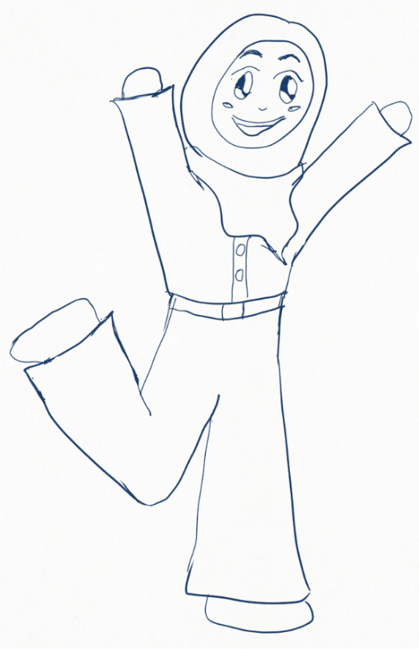
Scene Two: Wonderworld – Version B
At last, the girls had arrived at Wonderworld! It was Fatima’s favorite place. She jumped up high. “I can’t wait to ride the rollercoaster!” she squealed.

Yoko watched as the rollercoaster riders went zoom! They turned upside-down in loop-de-loops. When the riders all screamed, “Ahhhhh!” Yoko did too.
“It’s too fast!” she cried. Fatima noticed Yoko was shaking. “I don’t think it’s safe, Fatima!”

“I’m sure it’s safe,” said Fatima. “There are seatbelts and all the riders are laughing. Is something else wrong?”

“Yes,” said Yoko. “I am scared.”

Fatima gave her a big hug. “I’ll be right there with you, Yoko, don’t worry! – But if you don’t want to go, I won’t make you,” said Fatima.

Yoko smiled. “That makes me feel so much better, Fatima. Let’s go!”

Guiding Questions: Wonderworld– Version B
What happened in the story? How is it different from Version A?

Fatima asks Yoko if something is wrong after she notices something Yoko is doing with her body. What does she notice?

Yoko uses an I Statement to express that she is scared. Do you remember what an I Statement is? Use an I Statement to share how you feel today.

What is one reason Yoko feels scared?

At the end of the story, Fatima comforts Yoko. What does she do with her body to show her support for Yoko? What does she say?

What does Yoko decide to do at the end? If she made a different decision, how do you think Fatima would have felt? Show your answer using your face and body!

Creative Activity
What is your favorite ride at the amusement park? Draw Fatima, Yoko and yourself enjoying the ride!

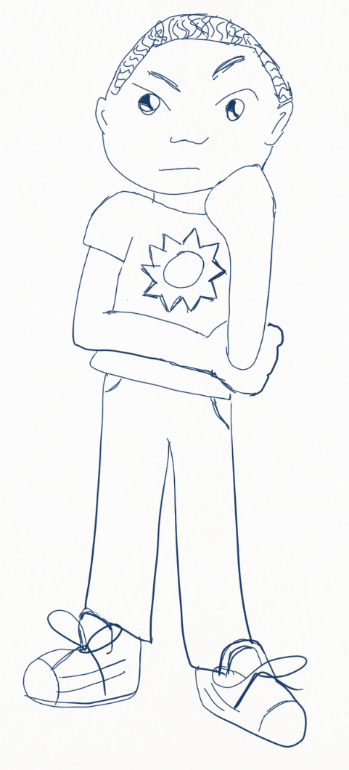
Scene Three: Bad Dog – Version A
After finally finishing their poster for art class, Aurora and Jamal played baseball in the yard until it was time for her to go home. When they came back, their poster had been ripped into little pieces!

“Oh no! What happened to our poster!” Aurora threw her hands in the air. “Maybe it was your dog.” She stomped her foot, looking for Fifi. Jamal just rubbed his chin and stayed quiet.
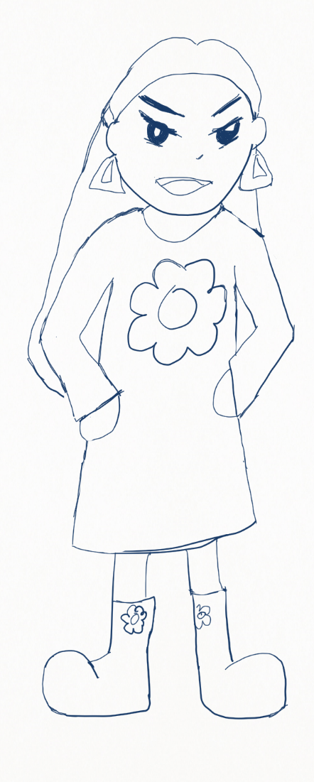
“Why aren’t you doing anything!” yelled Aurora, putting her hands on her hips. “I worked so hard and now I have to do it again. You don’t care!”

“Stop freaking out,” frowned Jamal. He looked closely at the torn paper.

“You’re a bad friend!” Aurora shouted, snatching the poster out of his hand and running home. After she left, Jamal began to cry.

Guiding Questions: Bad Dog – Version A
What happened in the story?

What is Aurora doing with her face or body to show how she feels after they find the poster ripped up? Show someone with your face and body.

How do you think Aurora feels when they find the homework is ripped up? Use the Feeling Friends Emotions Chart on page 5 and choose a word.

What is Jamal doing with his face or body to show how he feels after they find the torn poster? Show someone with your face and body.

What did Aurora say when Jamal said nothing? Repeat what she said while using your face and body to show how Aurora felt.

How do you think Jamal feels at the end of the story? Use the Feeling Friends Emotions Chart on page 5 and choose a word.

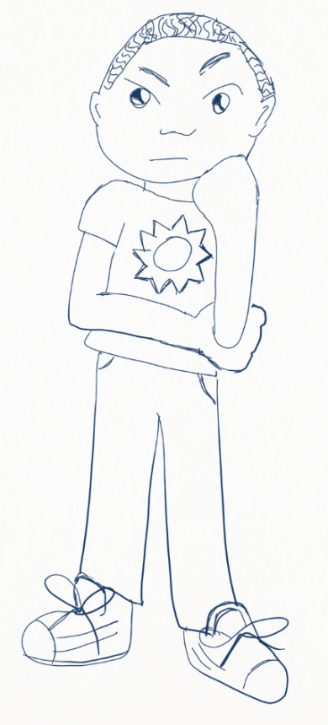
Scene Three: Bad Dog – Version B
After doing their poster for art class, Aurora and Jamal played in the yard. When they came back, their poster had been ripped into little pieces!

“I think your dog ate our poster!” Aurora growled. “I’m so upset!” Jamal watched her cross her arms.

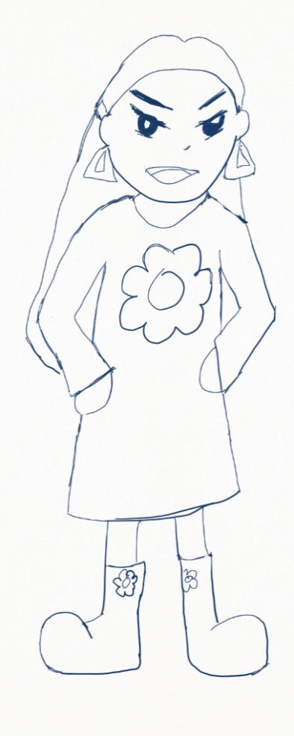
“I’m sorry, I know you worked so hard on that,” said Jamal. He rubbed his chin and went quiet.

“How are you feeling?” asked Aurora. “It was your poster, too! Aren’t you mad?”

“I’m feeling thoughtful,” said Jamal. “I don’t think it was the dog. I think something else happened. Can you help me find out? I trust you. You’re one of my best friends!”

Aurora smiled. “Thanks, Jamal, that’s very kind of you. Let’s look for clues. What if it was your baby brother?”

“I know! Maybe we can ask my parents if they saw what happened,” said Jamal. “I know we can solve this mystery together!” They both smiled and started looking for clues.

Guiding Questions: Bad Dog – Version B
What happened in the story? How is it different from Version A?

Jamal comforts Aurora after he notices something Aurora is doing with her body. What does he notice?

Aurora uses an I Statement to express that she is upset. Do you remember what an I Statement is? Use an I Statement to share how you feel today!

How do you think Jamal feels after finding the torn homework? Use an I-Statement to share how Jamal might feel.

In this version of the story, Jamal and Aurora say kind things about each other. What do they say? Find someone you care about and tell them something you like about them!

Creative Activity
Create your own poster with a friend. You can start by drawing something together. Without talking, take turns drawing lines and shapes until the picture is complete!

Chapter Two Review
Great job! As you read the scenes, you learned how to identify each Feeling Friend’s emotions and why they felt that way. We also learned how to express our emotions and respond to how our friends are feeling.

In version A of each scene, our Feeling Friends did not practice healthy emotional behaviors. But in version B of each scene, they did things that helped them and their friends solve their problems:
- They paid attention to their friends’ faces, bodies, voices and words.
- They guessed what emotion their friend might be expressing with their face, body, voice or words.
- When they weren’t sure, they asked their friends how they felt.
- They shared how they felt by using I Statements.
- They respected each other’s feelings.
- They treated each other with kindness.
- They worked together to solve their problems and help each other.

Use What You Learned
Can you remember a time when you or a friend didn’t understand how the other felt? What could you have done differently so you and your friend would have understood each other better? Say one thing you might have said to your friend while showing how you feel with your face and body.
Hint: Practice expressing how you feel using “I” statements like:

- I am happy
- I am sad
- I feel nervous
- I feel shy

Final Review
For each of the following pictures, use the Feeling Friends Emotions Chart on page 5 to choose a feeling word to describe that Feeling Friend’s emotion. Then act out the emotion using your face and body.

Rashida Anthony Yoko

Fatima Jamal Aurora

Great job! You’ve learned all about emotions. Now you’re a Feeling Friend too – congratulations!

Bonus Activity: Art Time
Hey Feeling Friend! You’ve definitely earned a fun reward for all your hard work.
Tear or cut out these Feeling Friend paper dolls and color them in. Fold the tabs under their feet to make them stand up, or cut these off if you want to lay them flat.

Here are some fun ideas:
- Draw places like a park, a school, the Wonderworld Amusement Park, Jamal’s yard (with Fifi!) – or your favorite place to go with your friends! -- and glue your Feeling Friends into your picture.

- Glue the Feeling Friends on paper plates before cutting them out and then put popsicle sticks on the back of each doll to make puppets. Act out favorite scenes from this book or fun new stories of your own creation!

- Decorate an old shoebox or small cardboard box to create a Feeling Friend Story Box and put your dolls inside. When you want to show how you’re feeling, reach into your Story Box and choose a Feeling Friend who feels the same emotion.

- What kind of adventure do you think Jamal and Anthony might have together? Or Yoko and Rashida? Fatima and Aurora? Mix and match your Feeling Friends and find out!

- Since you’re a Feeling Friend too, you’ll need your own paper doll! Use the blank doll on the last page to draw yourself as a Feeling Friend. Some tips:
  - How do you feel? Use the Feeling Friend Emotions Chart to find a word that describes your emotion
  - Draw yourself with a face showing this emotion!
  - What does your hair look like? Is it long or short? Draw your hair.
  - What is your favorite outfit? Draw yourself in your favorite clothes to wear.
  - Make your hair and clothes out of another material like construction paper and glue them on for more fun!
  - You don’t need to use this paper doll – feel free to draw your own!
