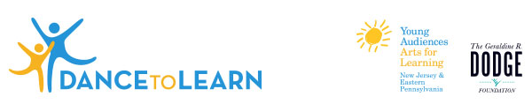
Grants Available to Dance Companies!
Deadline March 2
Returning Companies March 16

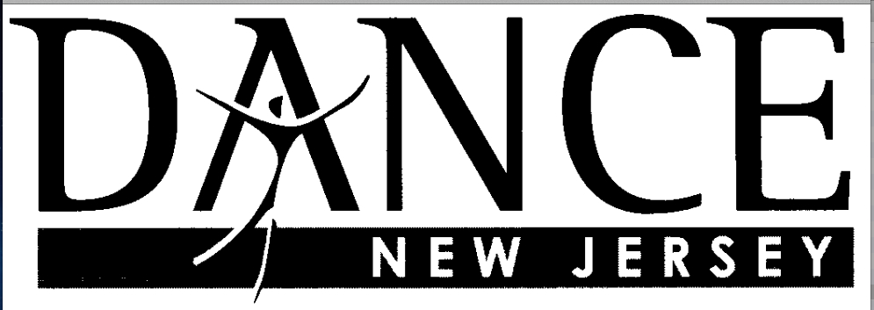

The Geraldine R. Dodge Foundation, Young Audiences New Jersey & Eastern Pennsylvania (YA) and Dance New Jersey are pleased to offer grants to up to 9 New Jersey dancers or dance companies. These grants are for further training in the field-tested, standards-based Dance To Learn Curriculum (D2L). Last year Derling Dance Arts, Diversified Applications for Dance, Freespace Dance, Lustig Dance Theatre, Nimbus Dance Works, Roxey Ballet Company, and 10 Hairy Legs were awarded grants to train and share the D2L curriculum in New Jersey schools.

If chosen, you and/or your company will work closely with an expert Young Audiences D2L trainer to prepare to bring this curriculum into the classroom. The grants provide funds for participation in training sessions, implementation of the D2L curriculum in New Jersey schools and a follow-up session with YA, Dance New Jersey, and participating D2L companies. .

Grant awards are dependent upon the number of applicants and size of the project proposed, but will range from $2,500.-$6,500.
Questions? Call Lisa Grimes at 973-222-8844

What you and/or your dance company get:
- One or two training sessions with your assigned Young Audiences D2L trainer to prepare to implement the curriculum in the classroom setting.
- Funding to bring a performance by your dance company to your partner school.
- Funding to implement a 10-16-day curriculum in classroom(s) at your partner school(s).
- Continued support from your Young Audiences D2L trainer through observation and conversations while implementing the residency.

Requirements:
- Attend D2L group training session on scheduled date (TBD after grants are awarded) and first year companies schedule a second training session with your assigned Young Audiences D2L trainer.
- Publicize the program to the local press (with YA assistance if necessary).
- Document through written, photo and video documents and assess student learning as prescribed by YA throughout the residencies.
- Complete a final report for Dance New Jersey and meet for a group debriefing.
- Complete all programming by June. 15, 2016 unless otherwise arranged with Dance New Jersey.

Application Deadlines
March 2 New Companies
March 16 Returning Companies

Dance To Learn Company Grant Application
Page 1 of 2
How to Apply:
- Complete the application by typing in the fields provided
- Print the application
- Sign the application (Artistic Director and Project Coordinator signatures are required)
- Scan to PDF and return it to Dance New Jersey via email to lisagrimes.dancenj@gmail.com
- Include at least one letter of support from a school you hope to work with
- Any questions pertaining to the application please call Lisa Grimes 973-222-8844

Name of Dancer/Company
Address
City
State
Zip
Phone
Fax

Required Signatures—please sign, scan and include in your application.
Artistic Director Signature
Artistic Director Name
Artistic Director Email
Project Coordinator Signature
Project Coordinator Name
Project Coordinator Title
Project Coordinator Email

Dance To Learn Grant Application
Page 2 of 2

Please answer the following questions adding no more than three pages (add separate pages as necessary):

- Describe the mission of your dance company and your commitment to arts education.

- Please list the names and locations of some schools where you currently work.

- Describe how you are currently working with schools through performances, residencies, workshops and/or professional development.

- Are you interested in or do you have experience with delivering arts-integrated curriculum? Please describe.

- List one to four possible partner schools you would like to work with on this project. Please include their location, the number of second, third, fourth and/or fifth grade classrooms you plan to work with, and any financial match the school will provide.

- When would you anticipate delivering the curriculum to your partner schools? (Programs must occur during the 2015/2016 school year and preferably conclude by June, 2016)

- Are you or your company a member of Dance New Jersey? If yes, how long have you or your company been a member? If No, call or email Lisa Grimes at 973-222-8844, lisagrimes.dancenj@gmail.com.

